Kubernetes Deployment Task – Step by Step Procedure

Step 1: Login to the server.
- First, login to the EC2 instance using MobaXterm.
Step 2: Become root user.
- Get into the killercoda site and perform the commands.

- Start with sudo su command to become as a root use.

- Type sudo su
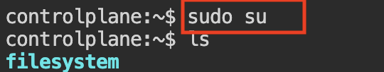

Step 3: Then create a namespace t20-as

- Type kubectl create ns t20-ns
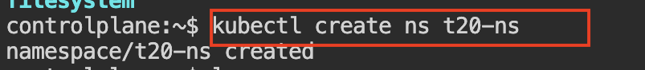
- This cmd is used to create the name-space.

Step 4: Create a directory name it as t20-dep-yaml-files

Type mkdir t20-dep.yaml
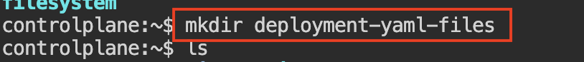
- This cmd is used to create a new directory.

- After creating the directory go into the directory.

Step 5:

- Type cd deployment-yaml-files
- this cmd is used to enter into the selected directory.

- In that directory create a file name it as t20-dip.yaml

Step 6:

- Type vi t20-dep.yaml
- This cmd is used to enter into the file so that we can add the yaml file in it.

Then paste the deployment code in the file.

apiVersion: apps/v1
kind: Deployment
metadata:
name: ipl-dep
namespace: t20-ns
spec:
replicas: 3
selector:
matchLabels:
app: ipl-app
template:
metadata:
labels:
app: ipl-app
spec:
containers:
- name: ipl-container
image: nginx:latest
ports:
- containerPort: 80

ESC
:wq

Step 7:

- Now apply the deployment file to run other process.

- Type kubectl apply -f t20-dep.yaml
- this cmd is used to run what all the data presented in the yaml file.

Step 8:

To check all the pods

- Type kubectl get all -n t20-ns

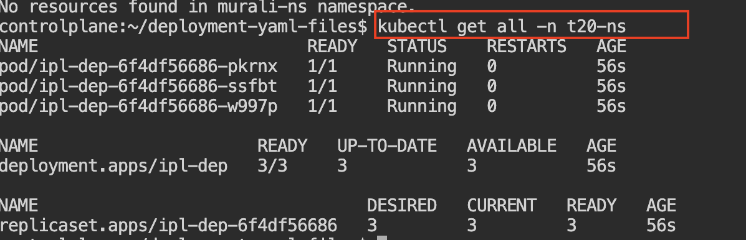
- This cmd is used to check all the running pods.

Step 9:

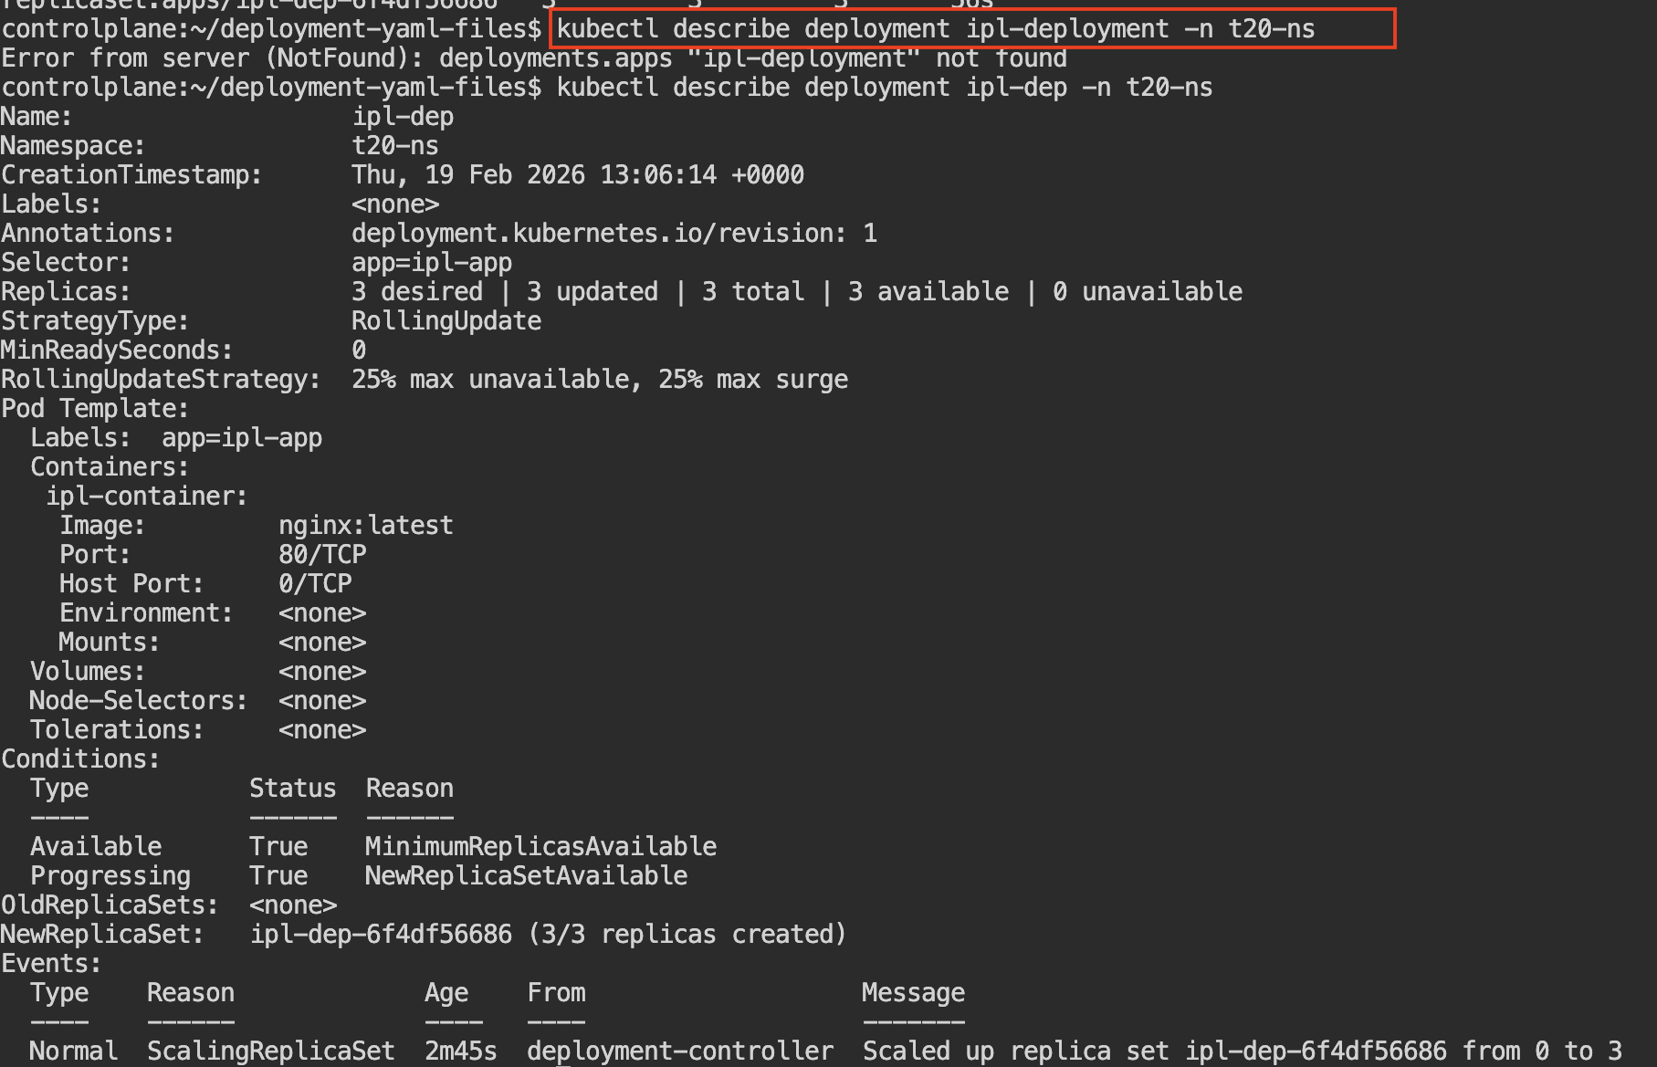
- Now It shows complete details about the deployment.

- Type kubectl describe deployment ipl-deployment -n t
Step 10:

- After completing the cmd now just copy the pod number and check with the command.

- Type kubectl describe pod ipl-dep-6f4df56686-pkrnx -n t20-ns

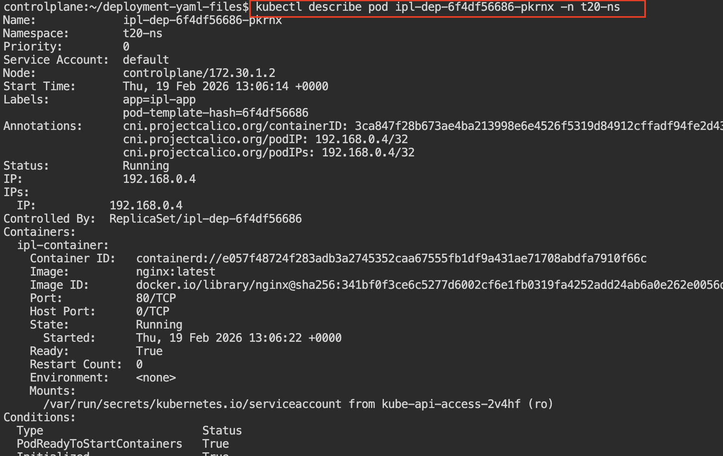

Step 11:

- It checks and shows the real-time status of the deployment update (whether the rollout is successfully completed or still in progress).

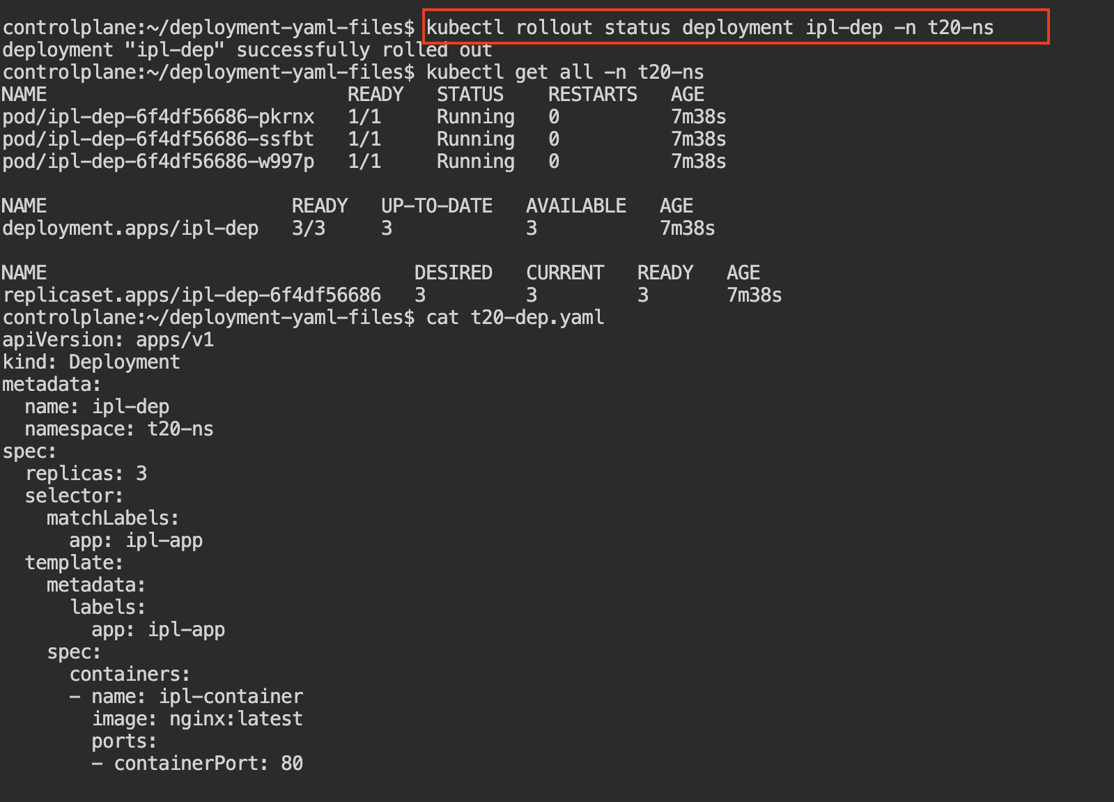

- Type kubectl rollout status deployment ipl-dep -n t20-ns

Step 12:

It rolls back the deployment to the previous working version if the current update has issues.

Type Cmd : kubectl rollout undo deployment ipl-dep -n <namespace>
Step 13:

Final Verification, all resources should be in running state.

